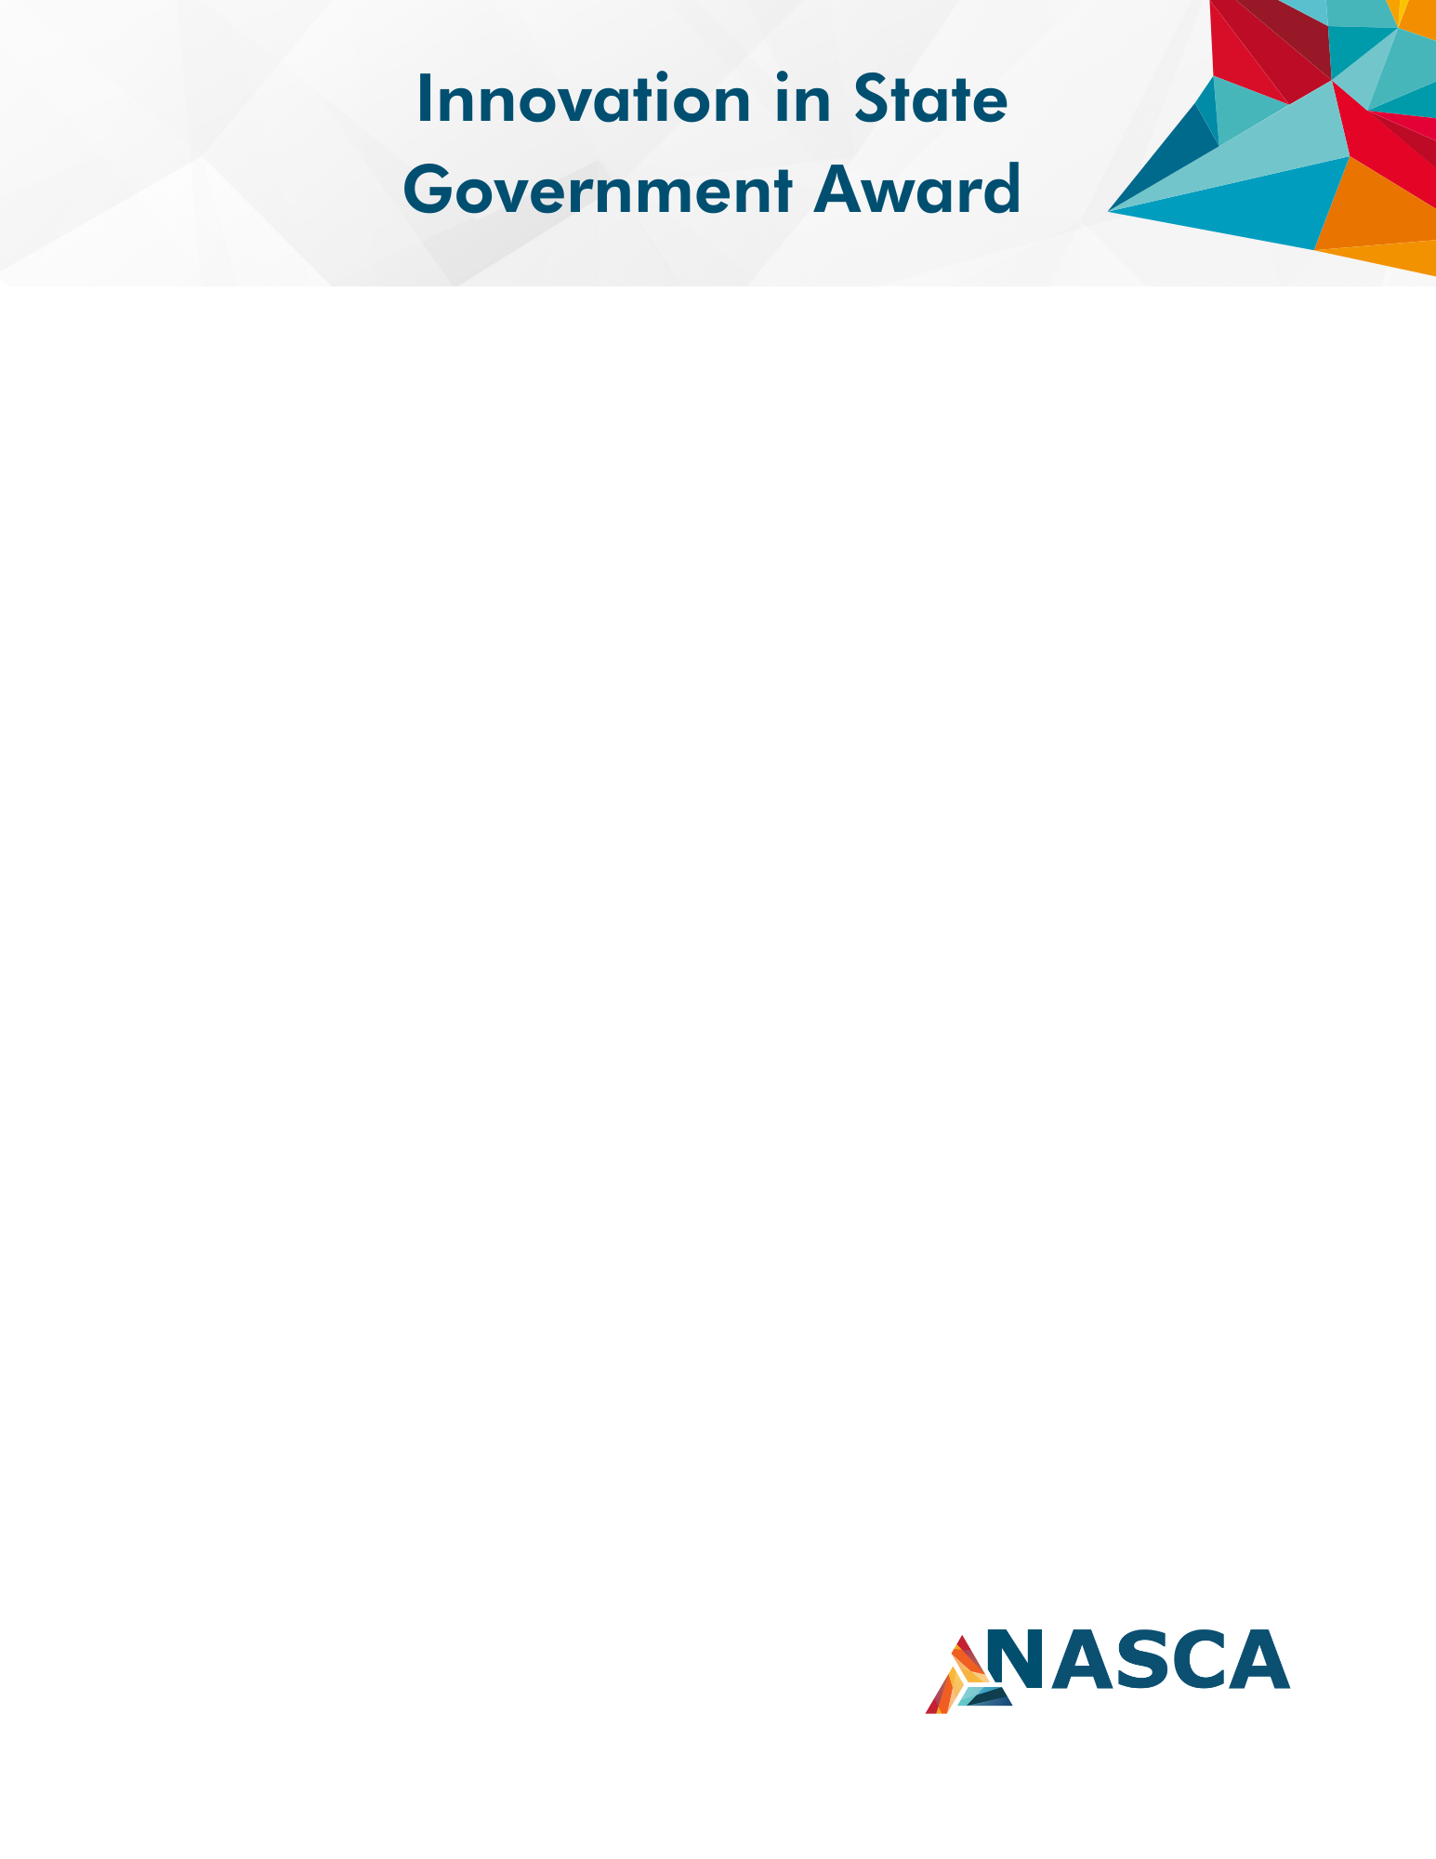

State of
[Insert Name]

Department of [Insert Name]

[Enter Submission Title Here]
[Enter Category Here]
This template will help guide your submission for review by the 2024 NASCA Awards Judges. It is recommended that you keep the headings as they are provided in this template for committee review. You may delete the guideline text in this template; it is listed to note how the committee evaluates each category and will not count against your page limits.

Please review guidelines and eligibility and submit the completed application by June 3, 2024. For questions contact programs@nasca.org

The Innovation in State Government Award will be awarded in each of seven categories to highlight new and innovative programs or projects that have produced efficiencies in the state based upon review and analysis.
Eligibility:
Nominations will be reviewed for eligibility and alignment with the category. The nominator will be notified of any concerns with the submission.
- State must be a current member of NASCA
- Submissions must be made by State Chief Administrators (or equivalent) or other state member with the State Chief Administrator's approval
- Nominated programs/projects should have implemented within the last 24 months
- Projects may be led by other agencies/departments, but staff from the administration department must have played a significant role in developing the program or project. (ex: HHS stockpile redesign, Department of Corrections recruitment and retention initiative)
- Only one nomination per state is allowed in each category, not multiple categories. Contact headquraters@nasca.org if you need help on the category selection
- A state may only be recognized as the award winner in two categories, the two highest scoring projects will be selected
- Only completed submissions will be accepted
- Submissions will only be accepted online
- Prior year submissions that were not awarded and have been updated can also be submitted
2024 Categories:
- Customer Service & Experience: Projects showcase a dedication to internal customer service strategies; building customer agency confidence, trust, and cross-boundary collaboration.
- Digital Services, Data Management, Analytics & Visualization: Projects showcase the transformative power of data for decision making and insight examples (e.g., predictive analytics, visualizations, performance management, data governance, data sharing or integration). Digital government projects improve interactions between partners (e.g., e-licensing, one-stop registration, permitting, payment, notifications).
- Diversity, Equity, and Inclusion in State Government: Projects include measurable diversification, systemic policy change, and excellence in removing unconscious bias.
- Employee Engagement and Experience: Projects showcase Employer of choice initiatives; impact on culture and recruitment/retention; talent growth & development; recognition, health, safety, and wellbeing, work perks, succession planning, and strategic workforce planning.
- Facilities and Real Estate Optimization: Project will include excellence in workspaces, including improvements to workforce productivity, sustainability, realigning owned portfolio, co-locating agencies, monetizing surplus property, deferred maintenance optimization, remotely scheduling and managing workplace resources
- Procurement Modernization: Project will include excellence in joint planning, sourcing, and procurement, scheduling of supplier and distributor activities, inventory management, warehousing, customer service.
- Transformation: Projects include prioritizing business process redesign, process improvement, spending where most effective, cost control, sustainable, savings opportunities focused on improved outcomes.

Judging Criteria:
Applicants will use a NASCA template that includes an executive summary and narrative of each of the following judging criteria. Visual aids are encouraged and may be included as supplemental material, but scores will be based on the written submission.
- Innovation: Project Goals/Objectives (25%)
- Strategy/Tactics (25%)
- Impact: Success Metrics/Outcomes and Efficiencies Achieved (50%)
Submissions are limited to five pages in addition to the title page, although optional supporting material can be submitted as a separate document when needed to showcase images, examples, or documentation that is too large to fit within the five-page submission itself.
Visual aids are encouraged and may be included as supplemental material, but scores will be based on the written submission.

Tips for a strong submission

- Remember to focus on what the project was intended to do and whether it achieved its stated outcomes.
- Tell a story of why this project matters.
- Focus on measurable outcomes. Back up your claims with statistics, visuals, and testimony, especially of the end user and citizen experience. This will be scored by your peers in the industry, but they won’t be aware of the obstacles and benchmarking in your state the project had to overcome.
- Keep it simple! Make sure entry is succinct, clear and focused on the judging criteria. Help break up text with key points.
- Try to interject your agency’s authentic personality.

Submissions are due to NASCA no later than June 3, 2024.

Executive Summary
Describe the project through an abstract/executive summary that illustrates the purpose and scope of the project and offers a brief overview of the implementation process. The introduction is not scored but should help the judges familiarize themselves with the project. The executive summary should not exceed one page and is included as part of the total page count for the submission.

Innovation: Project Goals/Objectives (25%)

Applicants should highlight what problem does this address? Why does the problem matter? What unique ways unique approach, scale, or magnitude of effort did the state undertake (point out differences and distinguishing the state from similar projects)? What makes this universal and transferable? What makes this project stand out as a notable contribution in state government operations? Goals should be broad and overarching, objectives should be expressed in specific and measurable terms.

Strategy /Tactics (25%)

Strategy/Tactics should outline the plan, strategy, tactics, resources, team, roadmap used to reach the goals and objectives set. In this section, describe for reviewers the practical ability for replication by other states and entities, including the resources needed for implementation. List how a project or initiative template can be used broadly by other states and note any geography, environment, governmental structure, or needs required for implementation. In some cases, it may be necessary to explain how an apparent state-bound effort can be adapted for greater transferability in other areas.

Impact: Success Metrics/Outcomes and Efficiencies Achieved (50%)

For the measurement of your goals and objectives applications should indicate the metrics used to measure success and why those measurements are a good indicator of what the project was hoping to accomplish. Examples include:
  - Number of hours saved, and hours saved were used in meaningful new ways
  - Employee engagement impact on retention
  - Increased customer satisfaction survey
  - Visits and use of the online data visualization

